

Division of Electronics and Communication Engineering
2025-2026 (EVEN SEM)

III IA EVALUATION REPORT

for

24EC2006-DIGITAL SIGNAL PROCESSING-
PROJECT BASED COURSE

Title of the project: Automatic Music Genre Classification Using MATLAB

A report submitted by

Name of the Student | Abijith Jay J
Register Number | URK24EC1044
Subject Name | Digital Signal Processing
Subject Code | 24EC2006
Date of Report submission | 13.04.2026

Project Rubrics for Evaluation
First Review: Project title selection - PPT should have four slides (Title page, Introduction, Circuit/Block Diagram, and Description of Project).
Second Review: PPT should have three slides (Description of Concept, implementation, outputs, results and discussion)
Rubrics for project (III IA - 40 Marks):
Content - 4 marks (based on Project)
Clarity - 3 marks (based on viva during presentation)
Feasibility - 3 marks (based on project)
Presentation - 10 marks
Project Report - 10 marks
On-time submission - 5 marks (before the due date)
Online submission-GCR - 5 marks
Total marks: _____/ 40 Marks

Signature of Faculty with date:


TABLE OF CONTENTS

CHAPTER | TITLE | PAGE NO.
 | INTRODUCTION | 1
 | DESCRIPTION OF THE PROJECT | 4
 | CONCEPT INVOLVED | 6
 | TOOLS | 8
 | IMPLEMENTATION | 9
 | RESULTS WITH GRAPH/SIMULATION | 13
 | INFERENCES | 15
 | CONCLUSION | 17

CHAPTER 1
INTRODUCTION
Music plays an important role in entertainment, communication, and digital media platforms. With the rapid growth of online music streaming services and digital audio libraries, the automatic classification of music into different genres has become an important area of research and application. Music genre classification is the process of identifying and categorizing a song into a specific class such as Classical, Pop, Rock, or Melody based on its audio characteristics. This helps in organizing large music collections, generating smart playlists, and improving music recommendation systems.
In this project, an Automatic Music Genre Classification System is developed using MATLAB and Digital Signal Processing (DSP) techniques. The main objective of the project is to analyze an input audio file and predict its corresponding music genre by extracting important audio features. MATLAB is chosen for this project because it provides powerful tools for signal processing, audio analysis, and graphical representation, making it highly suitable for DSP-based applications.
The system first accepts an audio file in WAV or MP3 format and preprocesses it by converting stereo audio into mono. To reduce computation time and improve classification efficiency, a 10-second clip from the middle portion of the song is selected for analysis. This section usually contains the chorus or the main instrumental portion of the song, which better represents the genre characteristics.
The selected audio clip is then processed using DSP concepts such as Zero Crossing Rate (ZCR), Fast Fourier Transform (FFT), Spectral Centroid, and Signal Energy. These extracted features provide numerical information about the rhythm, frequency distribution, and intensity of the music signal. Based on experimentally selected threshold values, the system classifies the song into one of the predefined genres using rule-based decision logic.
This project demonstrates the practical application of digital signal processing in real-world audio analysis and serves as an effective model for understanding music information retrieval systems. It also provides a foundation for future enhancement using machine learning and artificial intelligence techniques for more accurate genre classification.

CHAPTER 2
DESCRIPTION OF THE PROJECT
The project titled “Automatic Music Genre Classification Using MATLAB” is an application-oriented Digital Signal Processing (DSP) based system developed to automatically identify the genre of an audio file. In the present digital era, the number of music files available across streaming platforms, personal libraries, and online repositories has increased significantly. Manual organization of these large collections is time-consuming and inefficient. Therefore, an automated classification system that can identify the genre of a song based on its audio characteristics becomes highly useful in music recommendation systems, playlist generation, and digital media applications.
The main aim of this project is to classify songs into different genres such as Classical, Melody, Pop, and Rock using MATLAB. The classification is performed by analyzing the audio signal and extracting important features using Digital Signal Processing techniques. The project mainly focuses on converting the audio signal into meaningful numerical features and applying threshold-based decision logic to determine the genre.
The system begins by accepting an audio file from the user through a file selection dialog box. The accepted file formats include WAV and MP3, which are among the most commonly used audio formats. Once the file is selected, it is read using MATLAB’s built-in audioread() function. This function converts the audio file into a digital signal format, represented as a sequence of sampled amplitude values. Along with the audio signal, the sampling frequency of the audio file is also obtained. The sampling frequency indicates the number of samples recorded per second and is an important parameter in digital signal analysis.
Many audio files are stored in stereo format, meaning they contain two separate channels, namely the left and right channels. Since analyzing both channels separately increases computational complexity, the project converts the stereo signal into a mono signal by averaging both channels. This reduces processing time and simplifies further feature extraction while retaining the essential characteristics of the music.
To improve processing speed and enhance classification efficiency, the entire song is not analyzed. Instead, a 10-second clip from the middle portion of the song is selected. The middle section is usually chosen because it generally contains the chorus, instrumental highlights, or the main rhythmic structure of the song, which better represents its genre compared to the introductory or ending portions. This step also reduces the computational load, especially while working in MATLAB Online.
After preprocessing, the selected audio clip is played using MATLAB’s audio playback functions, allowing the user to verify the selected segment. The waveform of the signal is then plotted in the time domain. The time-domain representation shows how the amplitude of the audio signal varies with time and helps in visualizing beats, pauses, and intensity variations.
The next and most important stage of the project is feature extraction. In this stage, key DSP features are calculated from the audio signal to numerically represent its characteristics.
The first feature extracted is the Zero Crossing Rate (ZCR). ZCR measures how frequently the audio waveform crosses the zero-amplitude axis. It is an important parameter for understanding the rhythmic and transient nature of the signal. Songs with rapid beats and sharp transitions generally exhibit higher ZCR values, while smooth and soft songs have lower ZCR values.
The second major feature is obtained using the Fast Fourier Transform (FFT). The FFT converts the audio signal from the time domain into the frequency domain. This transformation is essential because the frequency content of a song plays a major role in determining its genre. For example, rock songs often contain stronger high-frequency components due to electric guitars and cymbals, while classical music may contain smoother and lower-frequency harmonic structures.
From the FFT spectrum, the Spectral Centroid is calculated. The spectral centroid represents the “center of mass” of the frequency spectrum and gives the average dominant frequency present in the audio signal. A higher centroid value indicates a brighter and sharper sound, while a lower centroid corresponds to smoother and softer tones.
The third feature extracted is Signal Energy, which represents the strength or loudness of the audio signal. Energy is calculated as the average squared amplitude of the signal samples. Songs with strong beats, drums, and intense instrumental sections usually have higher energy values compared to soft melodic songs.
Once these features are extracted, the system uses threshold-based decision logic to classify the music into a genre. Based on experimentally determined threshold values for ZCR, spectral centroid, and energy, the system checks the feature values against predefined conditions. For instance, lower centroid and ZCR values may indicate classical music, while higher centroid and ZCR values may suggest rock music. Similarly, other combinations of thresholds help identify pop and melody genres.
Finally, the predicted genre is displayed both in the command window and in a popup message box. Additionally, the frequency spectrum of the song is plotted for visual analysis. This graphical output helps in understanding how the frequency components vary across different genres.
This project successfully demonstrates the practical application of Digital Signal Processing in audio analysis and music classification. It provides a strong foundation for future enhancements such as machine learning-based genre classification, inclusion of additional genres, and development of a graphical user interface for real-time use.

CHAPTER 3
CONCEPT INVOLVED
The project “Automatic Music Genre Classification Using MATLAB” is primarily based on the concepts of Digital Signal Processing (DSP), audio signal analysis, and feature-based classification. The system works by converting an input audio file into a digital signal, extracting important signal features, and classifying the song into its corresponding genre using rule-based threshold logic. The major concepts involved in this project are discussed below.
The first fundamental concept involved is digital audio signal processing. Music or sound in the real world is naturally an analog signal, which varies continuously with time. In order to process this signal using MATLAB, it must be represented in digital form. This is achieved through the process of sampling, where the continuous audio waveform is converted into a discrete sequence of amplitude values at regular time intervals. The number of samples taken per second is called the sampling frequency or sampling rate, usually represented by $f_{s}$. Common audio sampling frequencies include 44.1 kHz and 48 kHz. This means that 44,100 samples are taken every second to accurately represent the sound signal in digital form.
Another important concept used in the project is signal preprocessing. Audio files are often stored in stereo format, containing two channels, namely the left and right channels. For simplified analysis, the stereo signal is converted into a mono signal by averaging both channels. This reduces computational complexity and ensures that the audio can be processed more efficiently without significantly affecting its characteristics.
The next major concept involved is signal segmentation. Instead of analyzing the complete song, a 10-second segment from the middle portion of the song is selected. This concept is used to reduce processing time and improve computational efficiency. The middle section is usually preferred because it often contains the chorus, dominant instruments, and the primary rhythmic structure of the song, which better represent the genre characteristics.
A key concept in the project is time-domain analysis. In the time domain, the audio signal is represented as amplitude versus time. By plotting the waveform, it becomes possible to visualize the variations in amplitude, beats, pauses, and intensity changes over time. This helps in understanding the structure of the signal before further analysis.
One of the most important DSP concepts used in the project is the Zero Crossing Rate (ZCR). Zero Crossing Rate refers to the number of times the audio waveform crosses the zero-amplitude axis within a given duration. It is mathematically defined as the rate at which the sign of the signal changes from positive to negative or vice versa. Songs with rapid beats, sharp transitions, and percussive elements generally exhibit higher ZCR values, whereas smooth and soft music such as classical melodies tend to have lower ZCR values. Therefore, ZCR serves as an important feature for distinguishing between different music genres.
Another major DSP concept involved is the Fast Fourier Transform (FFT). The FFT is an efficient algorithm used to convert the audio signal from the time domain to the frequency domain. While the time-domain waveform shows how the signal varies with time, the frequency domain reveals the different frequency components present in the audio signal. This is extremely useful for music genre classification because different genres have distinct frequency characteristics. For example, rock music often contains stronger high-frequency components due to guitars and cymbals, while classical music may have smoother harmonic frequency distributions.
From the frequency-domain spectrum obtained using FFT, the Spectral Centroid is calculated. The spectral centroid is an important audio feature that indicates the “center of mass” of the frequency spectrum. It represents the average dominant frequency present in the signal and is often associated with the brightness of the sound. Higher spectral centroid values indicate brighter, sharper, and more energetic sounds, whereas lower values indicate softer and smoother sounds. This concept is highly useful in distinguishing genres such as rock and classical music.
The project also involves the concept of signal energy. Signal energy is a measure of the strength or intensity of the audio signal. It is calculated by taking the average of the squared amplitude values of the signal samples. Songs with stronger beats, louder vocals, and intense instrumental sections tend to have higher energy values, whereas soft and soothing melodies have comparatively lower energy values.
The final concept involved is rule-based classification using threshold logic. After extracting the features such as ZCR, spectral centroid, and energy, the system compares these values with predefined threshold ranges. Based on these conditions, the song is classified into genres such as Classical, Pop, Rock, or Melody. This approach is known as feature-based threshold classification, where decision-making is performed using conditional statements.
Thus, the project integrates multiple DSP concepts such as sampling, preprocessing, time-domain analysis, frequency-domain analysis, FFT, spectral features, signal energy, and threshold-based classification to achieve automatic music genre detection.

CHAPTER 4
TOOLS
The primary tool used for the project “Automatic Music Genre Classification Using MATLAB” is MATLAB (Matrix Laboratory). MATLAB is a high-level programming and numerical computing software widely used in engineering applications, especially in Digital Signal Processing (DSP), communication systems, and control systems. It provides a simple programming environment along with powerful built-in functions for signal analysis, visualization, and mathematical computation.
This project was developed using MATLAB Online, which allows the code to be executed through a web browser without installing the software locally. It is especially useful for cloud-based storage and easy access to audio files and scripts.
Several built-in MATLAB functions are used as tools in this project. The uigetfile() function is used to open a file selection dialog box, allowing the user to choose an audio file in WAV or MP3 format. The audioread() function is used to read the selected audio file and convert it into a digital signal along with its sampling frequency.
For preprocessing, functions such as size() and mean() are used to check whether the audio is stereo and convert it into mono format. This simplifies the signal for further processing. The length() and floor() functions are used to determine the midpoint of the song and extract a 10-second clip from the middle portion.
For audio playback, the audioplayer() and play() functions are used to play the selected audio segment. MATLAB plotting functions such as figure(), plot(), xlabel(), ylabel(), and title() are used to display the waveform and frequency spectrum.
The most important DSP tool used in the project is the fft() function, which performs the Fast Fourier Transform to convert the signal from the time domain to the frequency domain. This is used for extracting important features such as spectral centroid. Other functions such as sum(), abs(), diff(), and sign() are used to calculate Zero Crossing Rate and signal energy.
Finally, logical tools such as if, elseif, and else statements are used for genre classification based on feature thresholds. These tools help in categorizing the song into genres such as Classical, Pop, Rock, and Melody.

CHAPTER 5
IMPLEMENTATION
The implementation of the project “Automatic Music Genre Classification Using MATLAB” is carried out using MATLAB programming and Digital Signal Processing techniques. The system is designed to take an audio file as input, process the signal, extract important features, and classify the song into a suitable genre based on predefined threshold values.
The implementation begins with the initialization stage, where the MATLAB workspace is cleared using the commands clc, clear, and close all. These commands are used to clear the command window, remove previously stored variables, and close all open figure windows. This ensures that the program starts in a clean environment without interference from previous executions.
The next step is the audio file selection stage. This is implemented using the uigetfile() function, which opens a file browser dialog box and allows the user to select an audio file in WAV or MP3 format. If the user does not select a file and closes the dialog box, the program checks this condition using an if statement and terminates the execution safely using the return command. This prevents runtime errors and ensures robustness.
After the file is selected, the audio is read using the audioread() function. This function converts the input audio file into a digital signal represented as a sequence of sampled amplitude values. At the same time, the sampling frequency of the audio file is also obtained. The sampling frequency is an important parameter in signal processing because it indicates the number of samples recorded per second.
The program then checks whether the selected audio is in stereo format by using the size() function. If the audio contains two channels, the signal is converted into mono using the mean() function. This is done by averaging the left and right channels, which reduces computational complexity and simplifies further processing.
In order to improve execution speed, especially in MATLAB Online, the entire song is not processed. Instead, a 10-second clip from the middle portion of the song is extracted. The midpoint of the signal is calculated using the length() function, and the starting and ending indices of the clip are determined using mathematical indexing logic. The selected portion is then stored as the new signal for further processing. This implementation reduces the processing time significantly while still preserving the main characteristics of the song.
The selected clip is then played using the audioplayer() function along with the play() command. This enables the user to listen to the chosen segment and verify that the correct portion of the song is being analyzed.
The next stage is the waveform plotting stage. A time axis is created using the sampling frequency, and the waveform is plotted using the plot() function. This provides a visual representation of the audio signal in the time domain, showing how the amplitude changes with time.
The core implementation of the project lies in the feature extraction stage. In this stage, important DSP features are calculated from the selected audio segment.
The first feature extracted is the Zero Crossing Rate (ZCR). This is implemented using the sign(), diff(), abs(), and sum() functions. ZCR measures the number of times the waveform crosses the zero-amplitude axis and provides information about the rhythmic and transient nature of the signal.
The second major feature is extracted using the Fast Fourier Transform (FFT). The fft() function is used to convert the audio signal from the time domain into the frequency domain. Since the FFT output is symmetric, only the positive half of the spectrum is considered for analysis. This is implemented by selecting the first half of the FFT output using indexing.
A frequency axis is then generated using the linspace() function. This axis is required for calculating the spectral centroid, which is one of the most important features for genre classification. The spectral centroid is implemented using the weighted average formula of the frequency magnitudes.
The next feature calculated is signal energy, which is implemented by squaring the signal samples and finding their average value. This gives the average power or intensity of the audio signal.
Once all the features are extracted, the implementation proceeds to the classification stage. The classification is performed using threshold-based decision logic with if, elseif, and else statements. Based on experimentally selected threshold values for spectral centroid, ZCR, and energy, the system assigns the song to one of the genres such as Classical, Pop, Rock, or Melody.
For example, if the centroid and ZCR values are low, the song is classified as Classical. If the centroid is high and the ZCR is also high, it is classified as Rock. Similarly, other threshold conditions are used for Pop and Melody.
Finally, the predicted genre is displayed in the command window using the disp() function and also shown in a popup window using the msgbox() function. Additionally, the frequency spectrum of the audio signal is plotted using the plot() function for visual analysis.
Thus, the implementation successfully integrates audio input handling, preprocessing, DSP-based feature extraction, and rule-based genre classification in MATLAB.

clc;
clear;
close all;

[file, path] = uigetfile({'*.wav;*.mp3'}, 'Select an audio file');
if isequal(file,0)
disp('No file selected');
return;
end
[x, fs] = audioread(fullfile(path, file));
if size(x,2) == 2
x = mean(x, 2);
end
clip_duration = 10;
mid_point = floor(length(x)/2);
start_idx = max(1, mid_point - floor((clip_duration * fs)/2));
end_idx = min(length(x), start_idx + clip_duration * fs - 1);
x = x(start_idx:end_idx);
player = audioplayer(x, fs);
play(player);

t = (0:length(x)-1)/fs;
figure;
plot(t, x);
xlabel('Time (s)');
ylabel('Amplitude');
title('Audio Waveform');
grid on;

zcr = sum(abs(diff(sign(x)))) / length(x);
X = abs(fft(x));
X = X(1:floor(length(X)/2));
f = linspace(0, fs/2, length(X));
centroid = sum(f'.*X) / sum(X);
energy = sum(x.^2)/length(x);
disp(['ZCR = ', num2str(zcr)]);
disp(['Centroid = ', num2str(centroid)]);
disp(['Energy = ', num2str(energy)]);
if centroid < 2500 && zcr < 0.08
genre = 'Classical';
elseif zcr > 0.13 && energy < 0.01
genre = 'Pop';
elseif centroid > 3000 && zcr > 0.12
genre = 'Rock';
else
genre = 'Melody';
end
disp(['Predicted Genre: ', genre]);
msgbox(['Predicted Genre: ', genre], 'Genre Classification Result');
figure;
plot(f, X);
xlabel('Frequency (Hz)');
ylabel('Magnitude');
title('Frequency Spectrum');
grid on;
disp(['Selected File: ', file]);
CHAPTER 6
RESULTS WITH GRAPH/SIMULATION
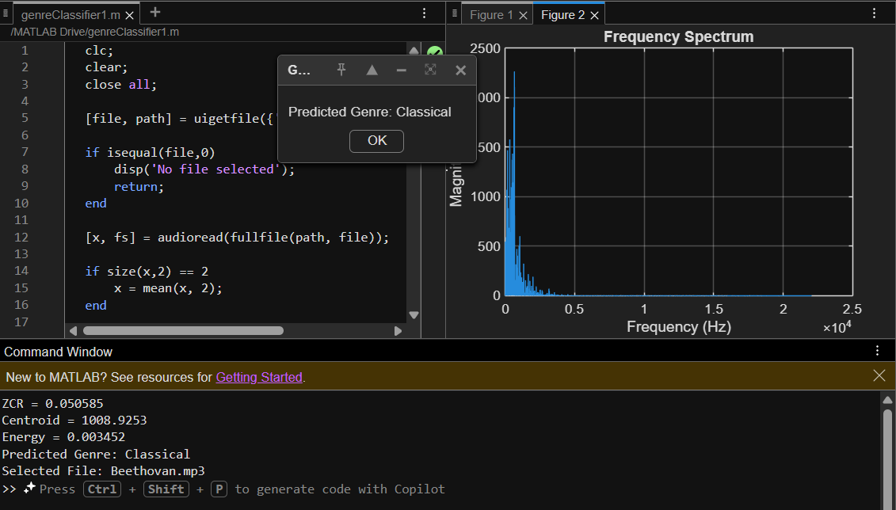Für Elise — Ludwig van Beethoven predicted as Classical Genre

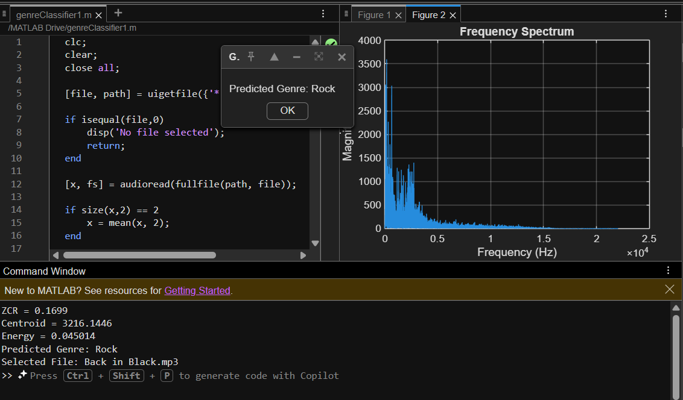 Back In Black — AC/DC predicted as Rock Genre

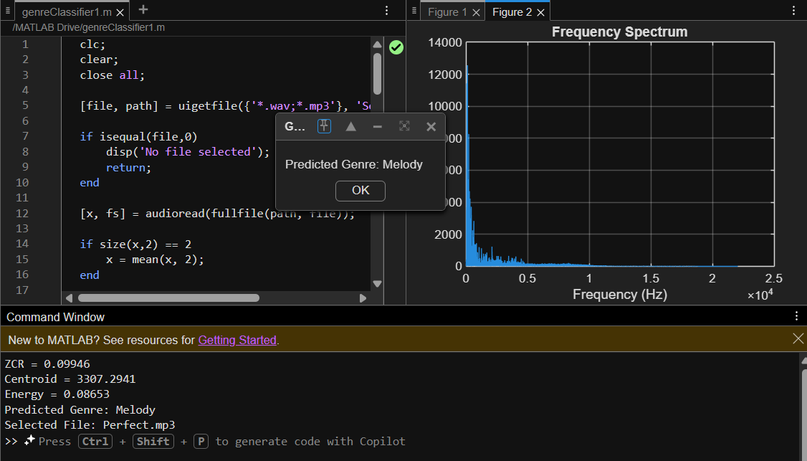 Perfect — Ed Sheeran predicted as Melody Genre

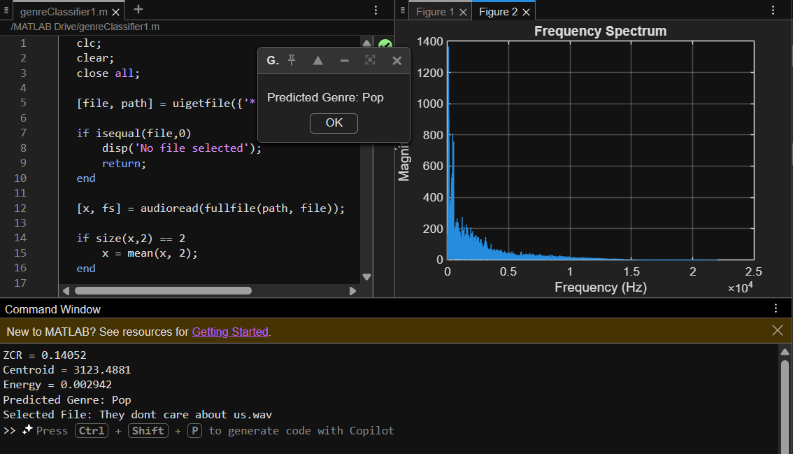 They Don’t Care About Us — Michael Jackson predicted as Pop Genre

CHAPTER 7
INFERENCES
The project “Automatic Music Genre Classification Using MATLAB” successfully demonstrates the practical application of Digital Signal Processing (DSP) techniques in the field of audio analysis and music information retrieval. From the implementation and testing of the system, it can be inferred that audio signals belonging to different genres exhibit distinct time-domain and frequency-domain characteristics, which can be effectively used for classification.
The extracted features such as Zero Crossing Rate (ZCR), Spectral Centroid, and Signal Energy play a significant role in identifying the nature of the music signal. During the testing phase, it was observed that songs with smooth transitions, soft instrumental tones, and lower dominant frequencies generally produced lower ZCR and centroid values, leading them to be classified under Classical or Melody. On the other hand, songs with stronger beats, rapid transitions, and higher frequency content produced comparatively higher ZCR and centroid values, which helped classify them as Rock or Pop.
From the waveform and frequency spectrum plots, it was clearly observed that each song possesses a unique signal pattern. The waveform plot helps in understanding amplitude variations and rhythmic structure, while the frequency spectrum reveals the distribution of frequency components across the signal. This confirms that frequency-domain analysis is more effective than direct time-domain observation when dealing with genre-based classification.
Another important inference from the project is that the middle 10-second segment of the song is sufficient to represent the essential characteristics of the music. This significantly reduces processing time while maintaining acceptable classification accuracy. It also proves that analyzing the chorus or main instrumental portion of the song is more useful than processing the complete audio file.
The use of Fast Fourier Transform (FFT) has been found to be highly effective in converting the signal into the frequency domain and extracting meaningful spectral information. The spectral centroid derived from the FFT output provides a reliable indication of the brightness and sharpness of the sound, which directly contributes to genre detection.
It can also be inferred that threshold-based classification logic is simple, easy to implement, and computationally efficient for small-scale genre classification tasks. However, during testing it was observed that some songs from different genres may occasionally fall under similar feature ranges, leading to slight misclassification. This indicates that while rule-based classification is effective for a basic project, more advanced techniques such as machine learning and neural networks can further improve accuracy.

Overall, the project successfully proves that DSP-based feature extraction combined with MATLAB implementation can be used to build an efficient and application-oriented music genre classification system. The project also provides a strong foundation for future work in intelligent audio signal processing and automated music recommendation systems.

CHAPTER 8
CONCLUSION
The project “Automatic Music Genre Classification Using MATLAB” has been successfully designed and implemented using Digital Signal Processing (DSP) concepts and MATLAB programming. The main objective of the project was to analyse an input audio file and automatically classify it into different music genres such as based on its signal characteristics. The project effectively demonstrates how DSP techniques can be applied to real-world audio processing applications. Classical, Pop, Rock, and Melody
The system begins by accepting an audio file in WAV or MP3 format, followed by preprocessing steps such as stereo-to-mono conversion and extraction of a 10-second segment from the middle portion of the song. This preprocessing stage improves computational efficiency and ensures that the most representative portion of the song is analyzed. The extracted segment is then processed using important DSP features such as Zero Crossing Rate (ZCR), Spectral Centroid, and Signal Energy.
The use of Fast Fourier Transform (FFT) plays a major role in the project by converting the signal from the time domain to the frequency domain, allowing detailed analysis of the spectral content of the audio. The extracted features provide meaningful numerical representations of the song’s rhythm, frequency distribution, and intensity. Based on these features, the system uses threshold-based decision logic to classify the song into the appropriate genre.
The results obtained from the project confirm that different genres possess distinct signal patterns and spectral properties, which can be effectively used for classification. The waveform and frequency spectrum plots further help in visualizing the characteristics of the music signal and understanding the differences among genres.
Overall, the project successfully achieves its objective of automatic music genre classification and demonstrates the practical implementation of DSP concepts in audio signal processing. It also provides a strong foundation for future improvements such as increasing the number of genres, improving classification accuracy, and integrating machine learning techniques for advanced music recognition systems.

